IS:240 LAB 1
In these exercises, you’ll use Oracle’s SQL Developer to review the tables in the AP schema that’s used throughout this book. In addition, you’ll use SQL developer to enter SQL statements and run them against these tables.
Make sure Oracle Database is running
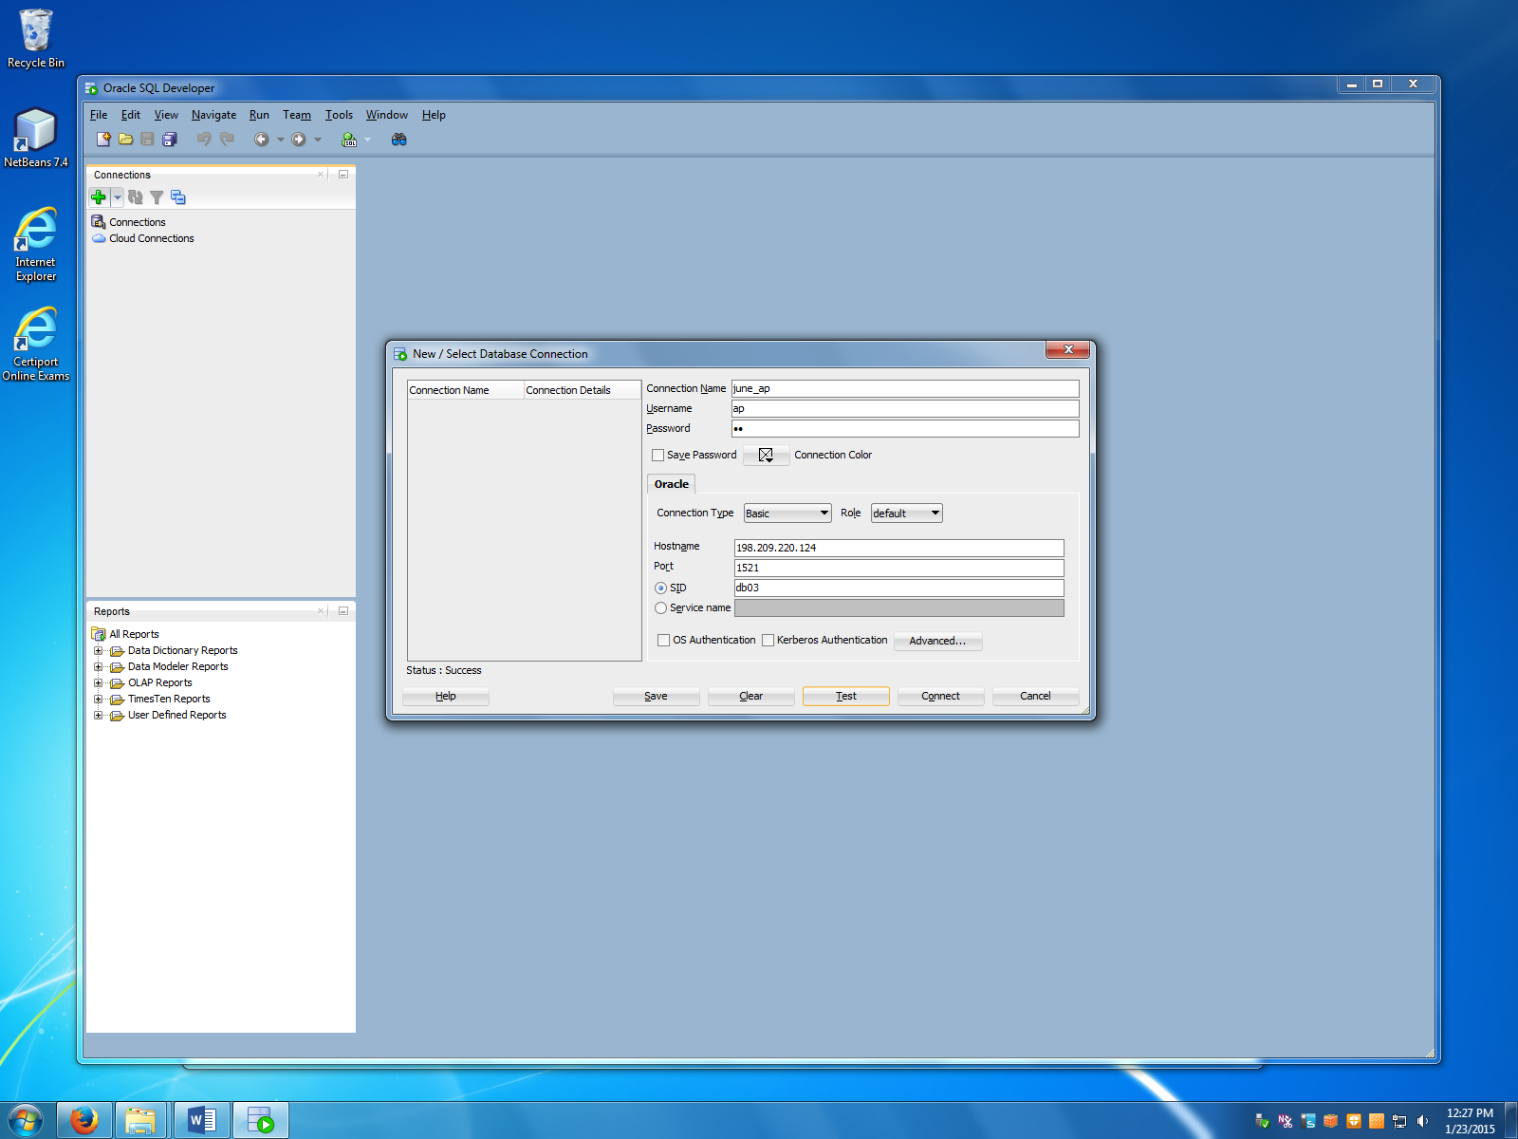

To connect to the college Oracle server remotely, enter the following information:
Connection Name: firstname_ap
Username: ap
Password: ap
Hostname: 198.209.220.124
SID: db03

Click Test to test your connection. If the status shows Success, click on Connect.
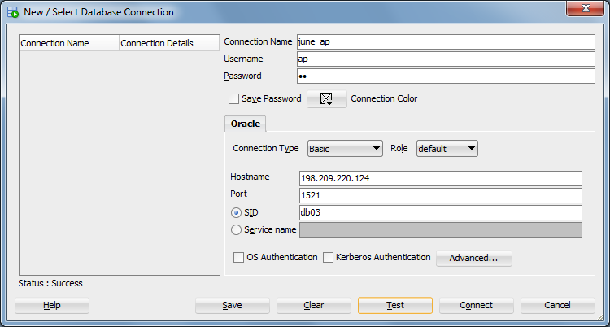
Use SQL Developer to enter and run SQL statements
- Use the technique described in chapter 2 to open a SQL Worksheet window for the AP connection. Then, enter and run this SQL statement:
SELECT vendor_name FROM vendors
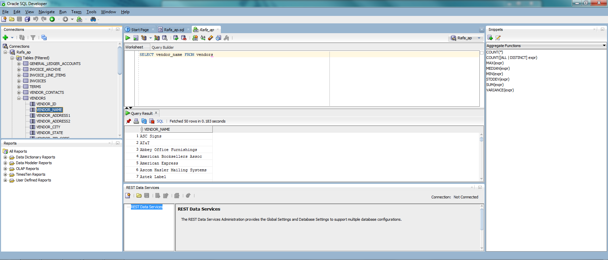

- Use the code completion feature described in chapter 2 to enhance this SQL statement so it includes an ORDER BY clause and some additional columns like this:
SELECT vendor_name, vendor_address1, vendor_city, vendor_state,
vendor_zip_code
FROM vendors
ORDER BY vendor_name
Then, run the statement.
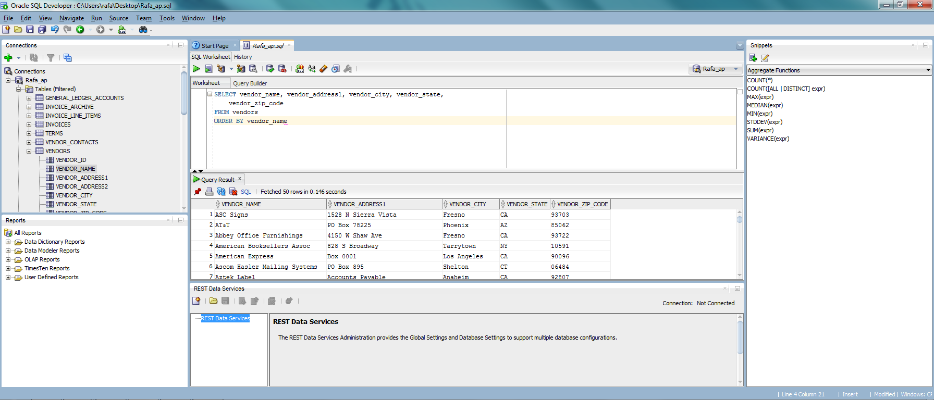
- Move the cursor into the ORDER BY clause and press Ctrl+/ to comment out the line. Then, press Ctrl+/ again to uncomment the line.
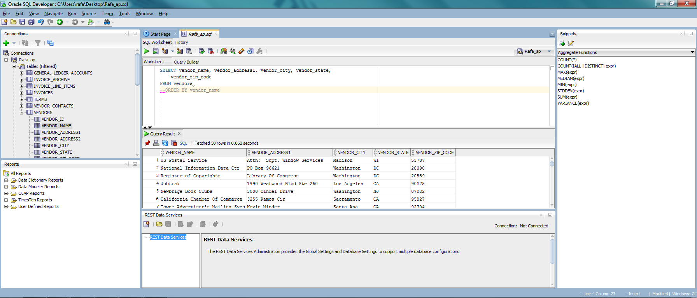

- Open another Worksheet window, and use the COUNT and SUM snippets as shown in chapter 2 as you enter this statement:
SELECT COUNT(*) AS number_of_invoices,
SUM(invoice_total) AS grand_invoice_total
FROM invoices
Then, run the statement.

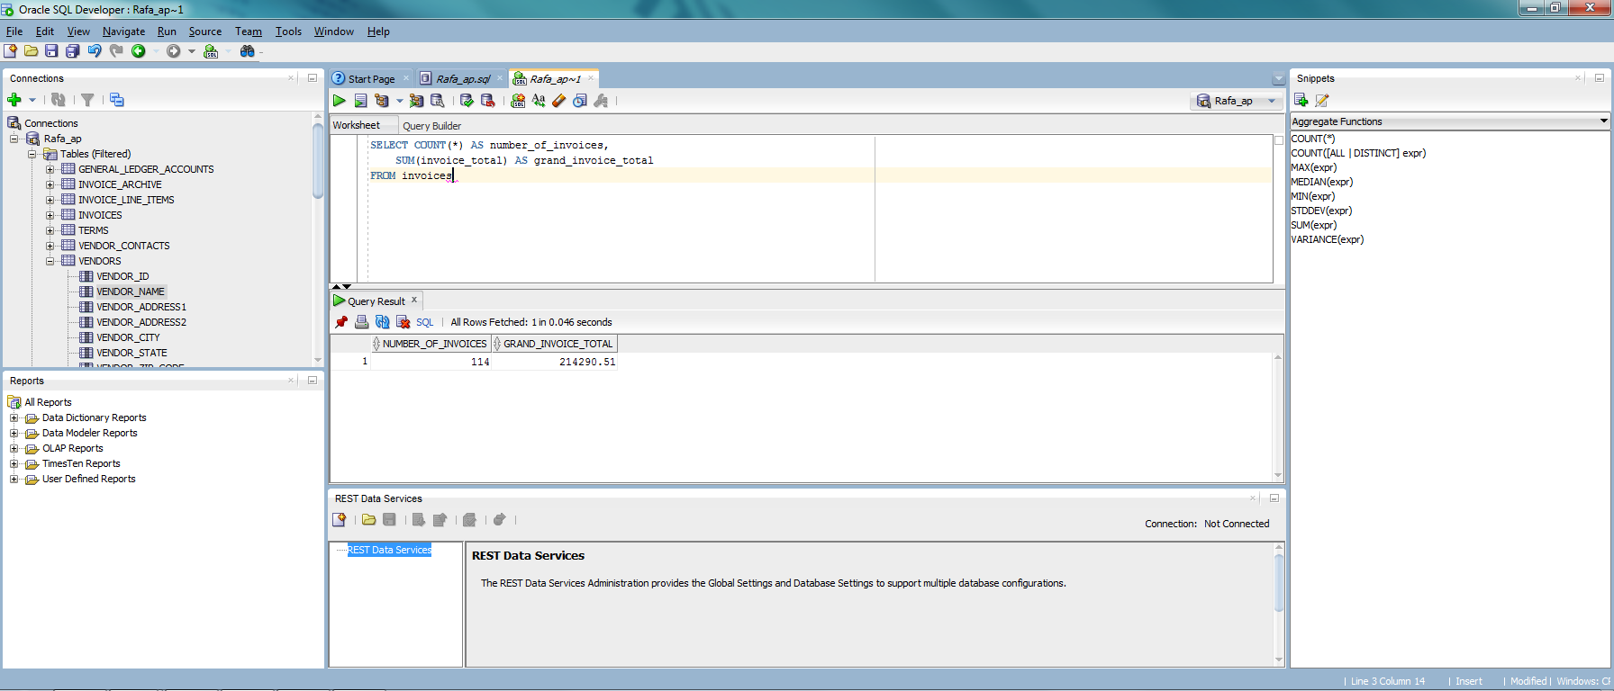

Close and restart SQL Developer
- Save your sql statement as a script file on your flash drive. Continue to experiment on your own. Make sure to leave at least one saved script open. When you’re ready to end this session, use the File→Exit command or click on the Close button in the upper right corner of the SQL Developer window.
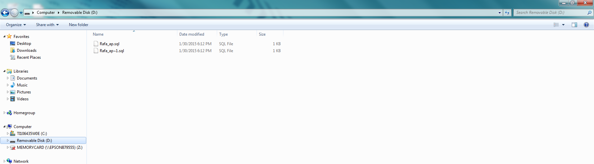

- Restart SQL Developer. When it starts, notice that all of the saved scripts that you left open are automatically opened. However, any unsaved scripts that you entered are lost.
- Run one of the open scripts. Note that you have to select a connection and provide a password for the connection before the script will run.
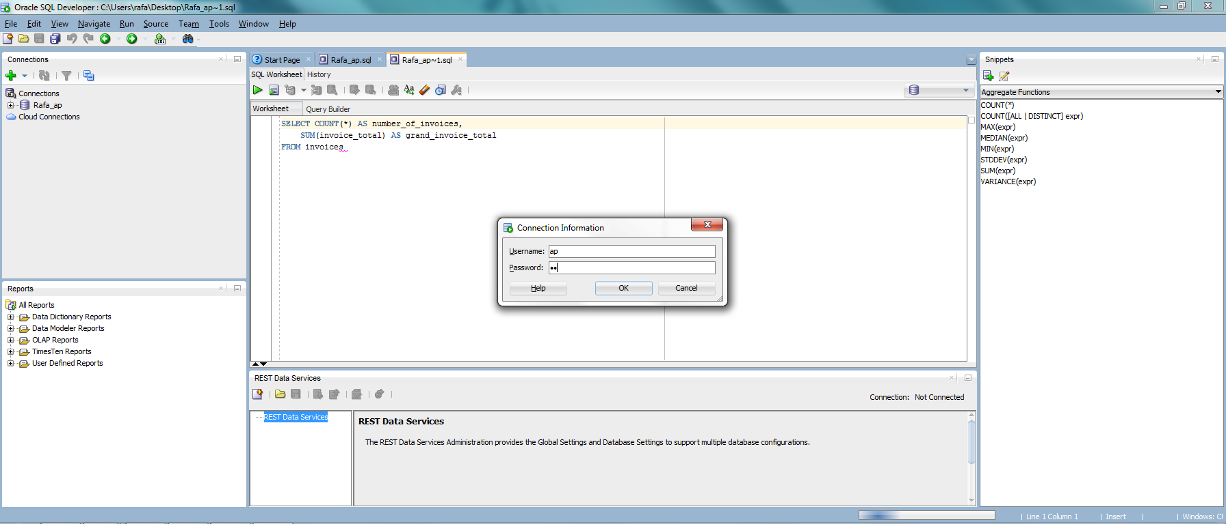
- Exit from SQL Developer.

